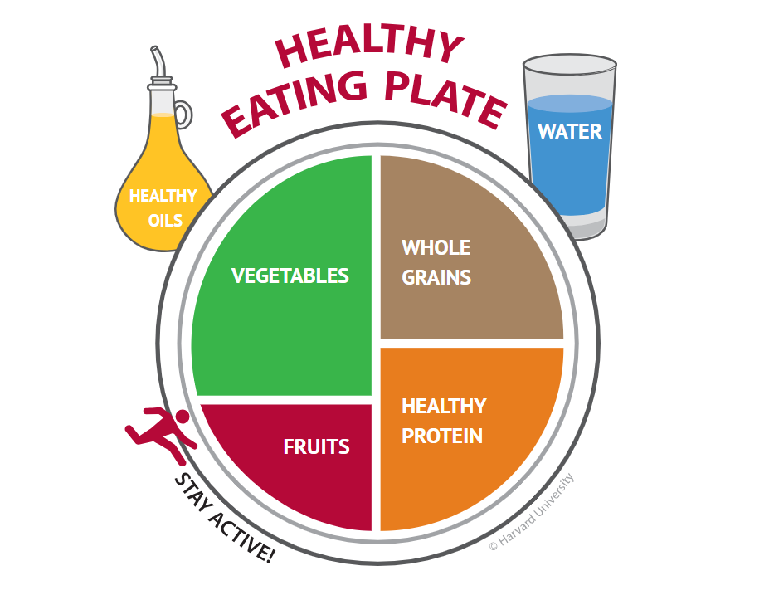

Best proteins: eggs, cottage cheese, full fat Greek yogurt, fish, beans, lentils, chicken, nuts, quinoa
Best fruits: apples, blueberries, bananas, oranges, dragon fruit, avocado, lychee, pineapple, strawberries
Best vegetable: spinach, kale, broccoli, peas, beets, carrots, fermented vegetables, tomatoes, onions, bell peppers, cauliflower, seaweed
Best whole grains: barley, quinoa, buckwheat, oats, farro, bulgur wheat, wild rice, millet, cereal
Best fats: fatty fish (tuna), chia seeds, dark chocolate, flaxseed, nut and seed butter, olives, yogurt
Most Beneficial spices: cinnamon, sage, peppermint, turmeric, basil, cayenne pepper, ginger, rosemary, garlic,

